Impact of Artificial Intelligence on Education in Young Adults (15–25 Years)

Shubham jain  Department of Computer Science and Engineering  Chitkara University Institute of Engineering & Technology, Chitkara University,  Punjab, India.  Email: shubham2365.be22@chitkara.edu.in | Kanika  Department of Computer Science and Engineering  Chitkara University Institute of Engineering & Technology, Chitkara University,  Punjab, India.  Email:  kanika1735.be22@chitkara.edu.inl

Abstract- In recent years, Artificial Intelligence has become a valuable educational technology that has helped young students with their education through technology. Students in the age range of 15-25 have begun using AI systems for answering questions, writing explanations, programming support, and assignments preparation. Although these technologies have helped increase accessibility and convenience in education, they may have some detrimental effects on reasoning ability and education imbalance.

This paper presents a predictive model to analyze the relationship between AI-supported learning and student performance. In this research, we will utilize the data containing 100 observations of students with features such as AI usage time, studying time, attendance percentage, previous scores, and dependency ratio. We will apply the linear regression technique to predict the current student performance based on the changing learning habits influenced by the AI technology.
We hope that our research helps quantitatively analyze the importance of AI in education and its role in becoming either an effective educational tool or a cause of dependency in young people.

Keywords: Artificial Intelligence, Education, Student Performance, Machine Learning, Academic Analytics, Linear Regression.

- Introduction
AI is among the greatest inventions in technology, which has changed how education takes place. It changes how knowledge is transferred from one individual to another within various educational environments.
In recent times, there has been an increase in digital learning tools, which include intelligent teaching and learning, assessment automation, and personalized academic support without relying completely on classroom learning.[1].

It is the group of young individuals aged between 15 and 25 years who are more engaged in applying the AI technologies in their studies. This group comprises high school and college students, who prepare themselves to be competitive in their respective areas. Young people employ intelligent devices to help answer their queries, condense the content, write codes, compose assignments, and comprehend difficult concepts. The development of platforms such as ChatGPT has helped them to achieve academic results fast.[2]

Recently, there has been inclusion of many technological educational ecosystems provided by leading technology companies such as Google and Microsoft in AI-based tutoring, automated testing, and personalized teaching. There have been developments that help track behavior, suggest suitable content, and engage users through adaptive responses.[3]

While there are some advantages, the sudden boom in AI-powered educational platforms has been linked to issues concerning dependency, mental degeneration, and a lack of independent reasoning. Most learners have come to depend on answers from AI systems rather than doing deep analysis, particularly in assignments, programming challenges, and theoretical questions. While this may make it easier for learners to complete a task, it may hinder their learning if not complemented by personal studies and theoretical work. [4]

Studies carried out by education scholars indicate that while AI systems facilitate faster responses and easy access to information, over-reliance may lead to poor retention and problem-solving skills. The students do not bother to verify the information they receive from AI software and, thus, cannot come up with unique arguments [5]. This is particularly important in higher education, where critical thinking skills are essential for development.

Through recent breakthroughs in machine learning, predictive models can now evaluate learner behaviors based on measurable educational metrics. These models predict future outcomes for students based on information such as their attendance records, hours spent studying, academic background, and learning trends. [6]. Such approaches are widely applied in educational analytics due to their capability to measure correlations between different behavior-related factors and student academic performance. The effectiveness of linear predictions models, classification methods, and intelligent learning analytics is proven by the successful study of student performance [7].

The use of regression analysis predictions is especially helpful for understanding how different aspects affect student performance. Student academic performance depends on various interdependent variables, including consistency, classroom engagement, and the application of resources. [8] One more essential variable that can influence student academic performance in an AI-assisted educational process is the extent of student dependency on the AI as opposed to self-study.

To be able to estimate the relationship between these two variables, the current research suggests using the variable "AI Dependency Index." It allows evaluating the correlation between time spent on AI use and time spent on self-studying per day. It helps determine whether the student uses AI as an academic support tool or relies on it instead of self-study. For example, when a student spends one hour on AI use and four hours on self-study, it demonstrates balanced AI application.

This study proposes a machine learning approach for examining the influence of
Artificial Intelligence on education among young adults aged 15-25 years. A data set is constructed by incorporating the academic variables of the number of hours spent using AI, study hours, attendance rates, previous scores, and current performance. The variables are then examined through Linear Regression to determine performance trends and changes in learning styles within AI-enabled settings.

The main objective of this research is not only to predict performance scores but also to ascertain whether AI improves educational efficiency in combination with consistent study practices. The framework also intends to deliver a clear educational approach that organizations can apply to scientifically analyze the effect of AI.

In addition to the above, the study explores visualizations of AI usage behavior, the influence of attendance rates, predictions of scores, and dependency distribution. This will assist in determining whether the balanced use of AI leads to stability in learning or whether its over-reliance causes an educational imbalance.

The primary objective is to construct an academic model promoting responsible AI usage that can contribute to the discourse on intelligent learning systems and digital transformation in education. This paper will follow the following format: Section II presents the background information and previous research; Section III covers the method and model; and Section IV concentrates on implementation and graphics.

- OBJECTIVE OF STUDY

The main aim of the research work is to study the influence of Artificial Intelligence on education in young people from the age of 15 to 25, specifically in terms of the effect on study patterns and academic results. As there are increasing AI integrations into the educational process, it should be established whether they are improving academic effectiveness or encouraging dependence on artificial intelligence technologies.

It is necessary to find out how AI affects learning balance against the background of self-study patterns and other elements, like attendance and previous grades.
.

The main purposes of the research include the following tasks:

  - To study the effects of Artificial Intelligence on academic performance.
  - To assess the influence of AI dependency on learning balance.
.
  - To forecast student achievements with machine learning algorithms.
  - To define an AI dependency measure.
  - To evaluate the impact of studying time, attendance and previous grades on students' results.
.

III RELATED WORK

Previous Research on education revealed the contribution of artificial intelligence to flexible learning and digitized access.

Wayne Holmes noted that AI helps facilitate adaptive learning through personalized educational approaches [1].

Rose Luckin highlighted that machine intelligence is to complement human intelligence, not compete [2].

Post 2020 research found that AI-based learning results in rapid responses but possibly less effort for conceptualization with unmonitored use [3].

Research into recent times has further established the role of generative AI instruments on assessment performance and study behavior in higher education [4].

Machine learning research has extensively included attendance records, previous grades, and learning behavior as predictors [5].

However, there is a paucity of work involving dependency ratio with respect to AI-based education.

- METHODOLOGY
The present research focuses on an examination of the impact of Artificial Intelligence on academic performance within the age group of 15 to 25 years old individuals through a predictive and quantitative methodology. The purpose of the research is to consider various measurable aspects of education and their interdependence in the presence of artificial intelligence within the learning process. With the increased use of artificial intelligence in education by influence of such technology on academic performance.
The methodology used includes several steps, namely data preparation, feature extraction, computing,
Dependency ratios, building machine learning models, and analyzing their performance.

- Research Design

In this study, the experimental design to be used will be a predictive study design that uses measurable variables to depict student learning behavior. The observation will be done within situations in which there are both artificial intelligence systems and conventional means of learning.

The variables chosen have proven to affect learning outcomes. They are easy to observe within the learning environment.
.

Dataset Preparation

Dataset creation:

For the analysis, we have created a dataset consisting of 100 student profiles. Each row corresponds to one student profile and consists of data related to the learning behavior of each individual.

This dataset includes the following features:

  - Age
  - AI Usage Hours per Day
  - Study Hours per Day
  - Attendance Percentage
  - Previous Marks
  - Current Marks

Feature Selection

The input variables used in this study are the ones that have a direct influence on the academic performance of students.

The input variables used include:

  - AI Usage Hours
  - Study Hours
  - Attendance Percentage
  - Previous Marks

The output variable used for predicting is:

Current Academic Marks

The above variables were selected since they represent

not only the academic discipline but also learning through AI technology.

- AI Dependency Index

In order to refine the analysis, an additional variable called the "AI Dependency Index" is incorporated into the research.

AI Dependency Index=AI Usage Hours/Study Hour s

Here, the AI Dependency Index compares the hours used to access AI resources against those used for studying independently.

Interpretation:

  - Less than 1 indicates balanced AI use
  - Equal to 1 indicates moderate dependence
  - Greater than 1 indicates high dependence
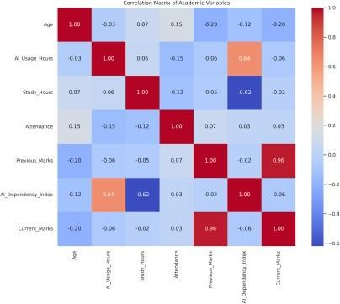

The AI Dependency Index provides an understanding of whether AI serves as a complementary aid or replaces self-study. Moreover, the model brings novelty by quantifying dependency and not just the frequency of use.
.

Prediction Algorithm

Linear Regression is chosen due to its clear depiction of interrelationships between educational factors.

Y=β0 +β1 X1 +β2 X2 +β3 X3 +β4 X4 +β5 X5
Where:

  - Y = Predicted Current Marks
  - X₁ = AI Usage Hours
  - X₂ = Study Hours
  - X₃ = Attendance
  - X₄ = Previous Marks
  - X₅ = AI Dependency Index

Model Training Procedure

The implementation is carried out in Python using standard machine learning libraries.

Libraries used:

  - pandas
  - numpy
  - matplotlib
  - sklearn
The dataset is divided into:

  - 80% training data
  - 20% testing data
During training, the model learns relationships between educational inputs and target academic output. Testing data is then used to evaluate prediction accuracy.

Performance Evaluation

The actual marks are then compared to the predicted marks to determine the accuracy of the prediction.

Graphical techniques adopted for this investigation comprise:

  - Scatter Plot
  - Line Graph
  - Bar Graph
  - Histogram

Graphs will aid in determining if there is any relationship between the use of AI and its dependence on performance.

GRAPHICAL ANALYSIS

Graph 1: Relationship between AI Use and Marks

Purpose:

To depict whether marks increase or decrease depending on the increase in the use of AI.

Graph 2: Attendance vs Academic Performance

Purpose:

To display the positive trend between attendance and marks.

Graph 3: Actual Marks vs Predicted Marks

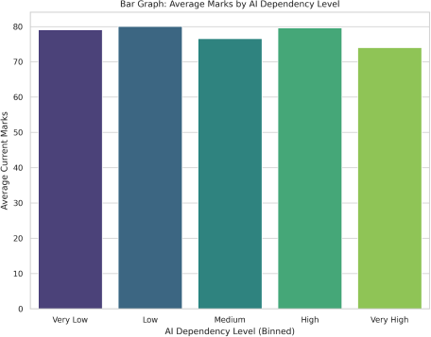

Purpose:

To compare the accuracy of machine learning predictions.

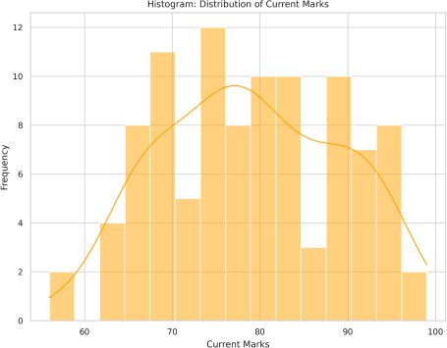

Graph 4: AI Dependency Index Distribution

Purpose:

To classify low, medium, and high dependency groups.

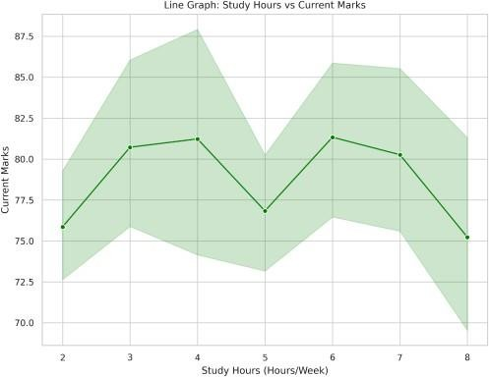

- RESULTS AND DISCUSSION

From The prediction model, the balanced use of AI in combination with consistent study helps enhance academic performance.

Students with consistent attendance and high grades tend to make accurate predictions.

Overreliance on AI usually results in less consistency because learners will not study consistently.

The dependency ratio provides better insights into performance variations than AI utilization.

- CONCLUSION

The use of Artificial Intelligence in educational support is gaining prominence among young adults in academic settings.

This research validates that there is an improvement in efficiency by utilizing AI as a learning assistant, rather than substituting self-study.

A metric to gauge dependency gives greater clarity on academic performance.

Future research could consist of:

  - Actual survey data from institutions
  - Comparison between neural network
  - Predictions based on subjects

- REFERENCES

- Holmes, W. (2019). Artificial Intelligence in Education

- Luckin, R. (2018). Machine Learning and Human Intelligence
- Chen, L. (2021). AI in Personalized Learning
- Kasneci, E. (2023). ChatGPT in Education
- Romero, C. (2017). Educational Data Mining
- Baker, R. (2016). Learning Analytics
- Kotsiantis, S. (2012). Student Performance Prediction
- Ouyang, F. (2022). AI Research in Education
- Viberg, O. (2023). Student AI Dependency
- Ifenthaler, D. (2020). Learning Analytics Use
- Roll, I. (2016). AI and Tutoring Systems
- Tlili, A. (2023). Generative AI in Learning

